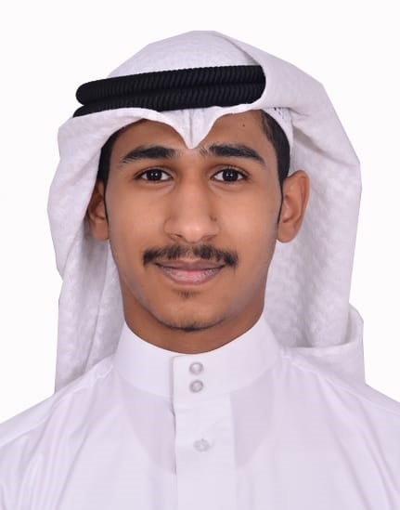**NASSER ALI HASAN JUMA**

**Address:** H.3899 B.745 R.4591 Sanad

**Phone:**37133649

**Email: nasserali2001sanady@gmail.com**

**PERSONAL INFORMATION**

**Marital status:** Single **Nationality:** BAHRAINI **CPR:**011005246

**Date of Birth:** 16-oct-2001 **Sex:** male

**EDUCATION**

* 1. Sheikh Abdullah bin Isa Al Khalifa Industrial Secondary school “IT”

**LANGUAGES AND OTHER SKILLS& ABILITIES**

Arabic, English (Good in speaking, reading and writing).

Ability to operate Microsoft Office Applications.

Working under pressure

**REFERENCES**

Available upon request